Midterm – DC Crashes Analysis
ALY 6070: Communication and Visualization for Data Analytics
Date: 08/06/2025
Instructor: Professor Jack Bergersen
Term: Summer 2025
Group 2:
Ruman Liu
Junhui Hu

Introduction
We set out to recreate our Tableau prototype in Qlik Cloud, aiming to explore over 333,000 traffic accident records in Washington, D.C. Our objectives were to identify high-risk corridors, reveal monthly trends by crash severity, and compare vehicle types involved in collisions.
To begin, we loaded the raw datasets into the Data Load Editor. Because the timestamp field FROMDATE stored as strings, so we used Date#(LEFT(FROMDATE,19),'YYYY/MM/DD hh:mm:ss') AS FromDate_Clean. This produced a native date, from which we derived five calculated fields: Year_Category grouping into “Before 2000,” “2000–2010,” and “After 2010”; MonthName plus MonthNum for correct sorting, Day_Night based on hour of day, Severity_Level via nested If() statements mapping Y/N flag into “Fatal,” “Major Injury,” “Minor Injury,” or “Property Damage Only”; and Total_Deaths summing five Fatal_* fields with Alt() to treat nulls as zero. These transformations ensured our subsequent visualizations would rely on clean, properly typed dimensions and measures.
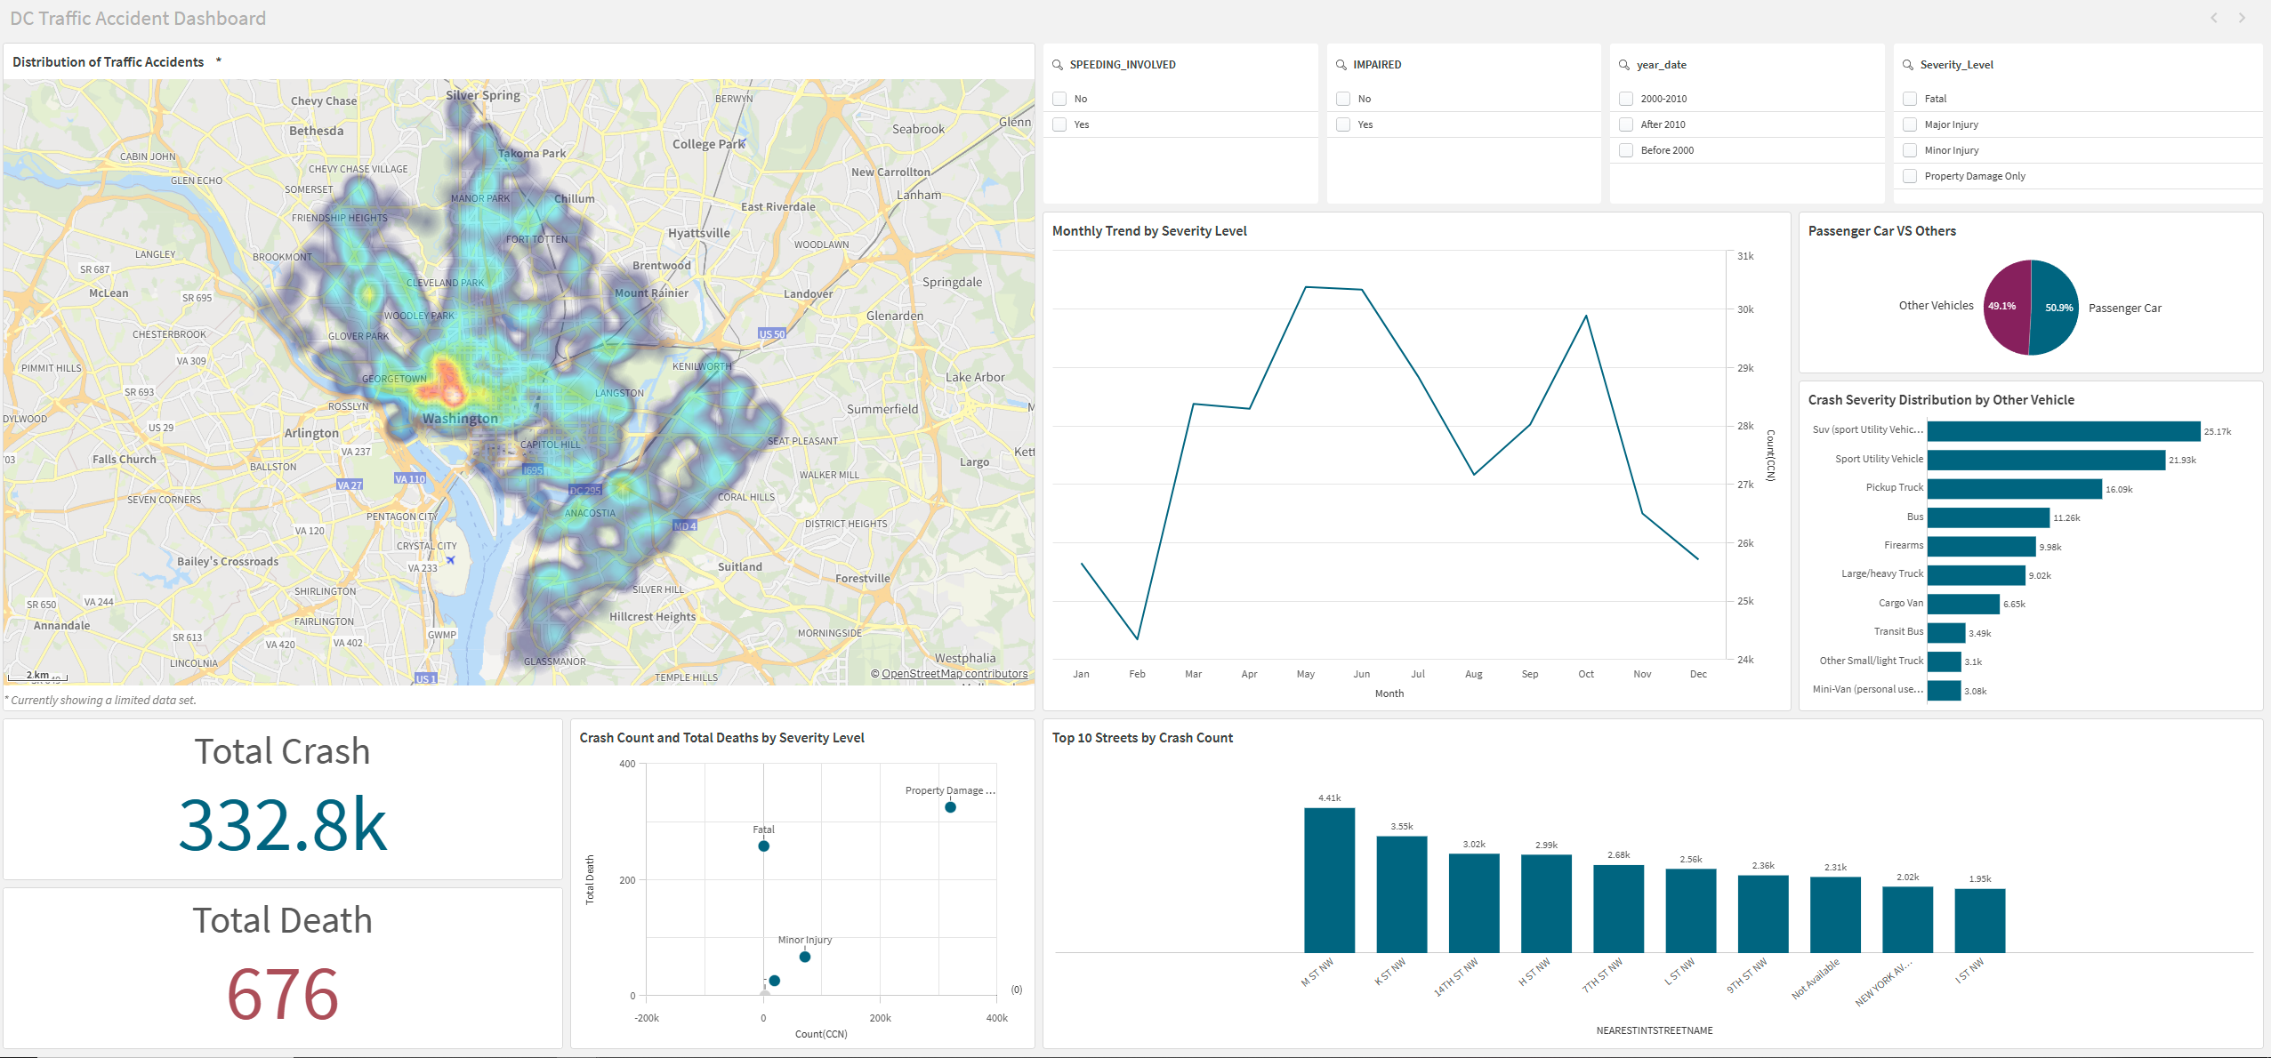

Distribution of Traffic Accidents
With a clean date field, we built a density map overlaying crash locations on D.C.’s basemap. Filtering by ‘Year_Category’ reveals that post‐2010 incidents concentrate around nightlife corridors, while Day_Night toggles expose peaks after 6 PM. Converting numeric fields like speeding into text (If(SPEEDING_INVOLVED=1,'Yes','No')) solved our second challenge. Which aligning filter pane labels consistently.
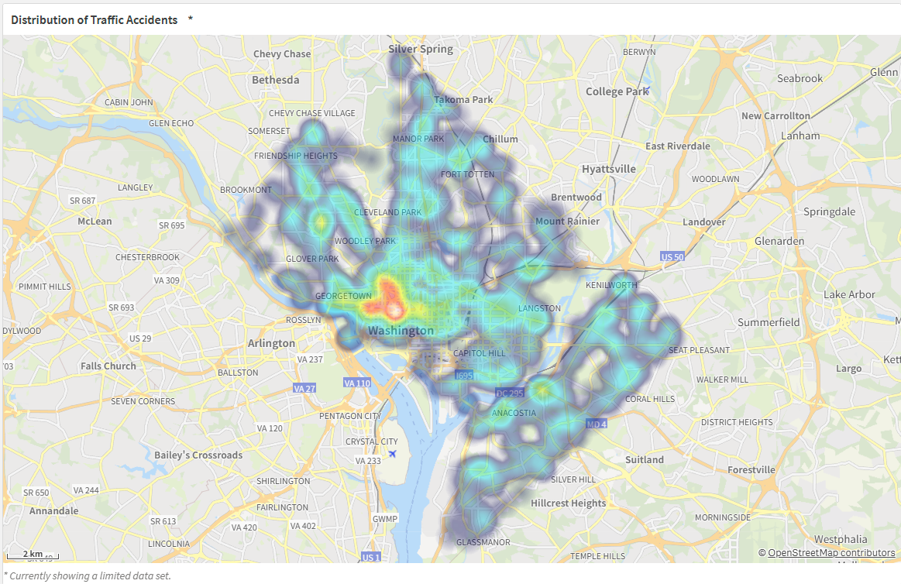
Top 10 Streets by Crash Count
Next, we tackled identifying the top 10 crash‐count streets. The raw NearestStreetName dimension contained blanks and Unknown, which made misleading tallies. So we applied set analysis in our bar‐chart measure (Count(DISTINCT {<NearestStreetName-={'','Unknown'}>} CrimeID)) and activated a Fixed Number limitation of Top 10 sorted descending by that measure. This two‐step fix eliminated junk values and surfaced true hotspots: M St NW, K St NW, and H St NW.
From the professor’s feedback that when data labels are displayed directly on bars, background gridlines and fine tick marks only add cognitive load. So, we disabled the chart’s horizontal gridlines and axis ticks, relying solely on on-bar labels to communicate exact counts.
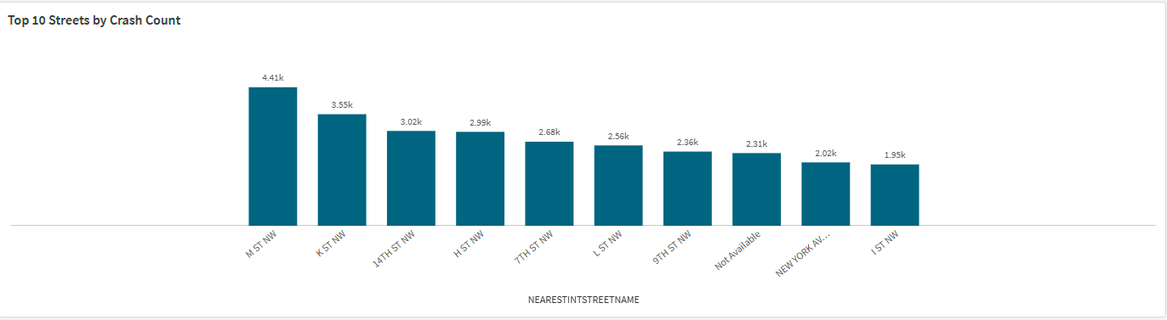

Monthly Trend by Severity Level
On the “Seasonal Trends by Severity Level” sheet, we set out as beginners to mirror our Tableau view of four colored lines—fatal, major injury, minor injury, and property-damage only which plotted over the twelve months, only to discover that Qlik’s standard line chart cannot accommodate vastly different scales side by side. In Tableau we could simply assign separate axes or adjust to a log scale, but in Qlik that option isn’t available, nor could we find a way to automatically flag the single highest point on each curve. Instead, we leaned on the filter pane that built from our clean date field and year-category dimension can let viewers choose one severity level at a time, so they can focus on, for example, the fatal-crash trend without the property-damage line dwarfing it. By disabling gridlines and tick marks and relying on direct data labels, we kept the visualization uncluttered while preserving full interactivity, and although our highest-point labeling remains manual, users can easily spot the fatal peak in October, the major-injury summit in April, the minor-injury climb in November, and the property-damage high in May through the filters we provided.
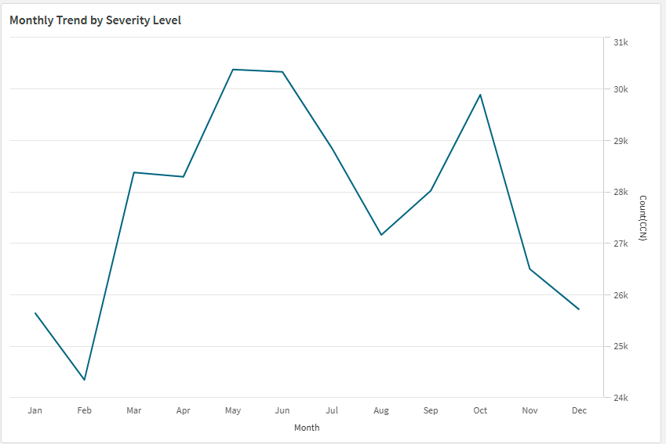

Crash Severity Distribution by Other Vehicle
On our “Vehicle‐Type Breakdown” sheet, we began by plotting a simple pie chart in Qlik to compare passenger cars against other vehicles, only to find that empty or undefined groups cluttered the view and that we could not automatically highlight the most frequent slice. To fix this, we created a calculated dimension using If(Len(Trim(Vehicle_Group))>0, Vehicle_Group) which filtered out all null, blank, or “Unknown” entries, and then enabled the legend so that each category label appeared clearly at the side. When we drilled down into “Other Vehicles,” we wanted to show only the top ten types by crash count, excluding passenger cars and “None.” Rather than rely on a separate Top N chart type, we applied set analysis in our measure: Count({<Vehicle_Type-={'*Passenger Car*','None'}>} CrimeID). And set a fixed-number limitation of ten in the dimension settings. We also moved data labels outside the bars and turned off gridlines so the counts stood out. Although Qlik did not let us flag the single highest vehicle type automatically with a distinct marker, users can employ the filter pane to select individual vehicle categories or severity levels for closer inspection. In the end, SUVs and Sport Utility Vehicles emerged as the most crash‐prone “other” types, and minor injuries consistently made up the largest proportion across almost all categories, confirming our findings in a clean, interactive Qlik dashboard.
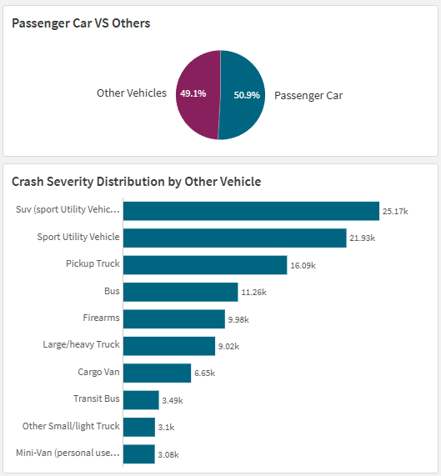
Conclusion
In conclusion, rebuilding our Tableau dashboard in Qlik Cloud was an eye-opening learning journey.We like how Qlik’s powerful scripting language let us preprocess and standardize messy data, deriving year and month fields, and creating conditional dimensions (something that in Tableau often requires awkward workarounds). At the same time, we discovered it is too simplistic to say Qlik is “less flexible” than Tableau. Tableau, by contrast, often feels more intuitive for rapid visual experimentation—dragging and dropping to create dual axes, dynamic reference lines, or automatically flagged peak points is almost effortless. In Qlik, those same “creative flourishes” sometimes require more manual steps or workarounds, which can feel frustrating at first. Yet that challenge also pushed us to deepen our expression skills and think strategically about what truly adds value to a dashboard. We learned to lean on interactive filters and clear on-bar labeling. In the end, Qlik and Tableau share the same goal but getting there can look very different. Our project underscored that mastering both platforms makes us a more versatile analyst, comfortable switching between the no-code speed of Tableau and the code-first power of Qlik.

Reference
Date#() – Text to Date Conversion. https://help.qlik.com/en-US/qlikview/May2024/Subsystems/Client/Content/QV_QlikView/Scripting/InterpretationFunctions/date_hash.htm?utm_source=chatgpt.com
Alt() – Handling Nulls. https://help.qlik.com/en-US/cloud-services/Subsystems/Hub/Content/Sense_Hub/Scripting/ConditionalFunctions/alt.htm?utm_source=chatgpt.com
WildMatch() – Pattern Filtering. https://help.qlik.com/en-US/cloud-services/Subsystems/Hub/Content/Sense_Hub/Scripting/ConditionalFunctions/wildmatch.htm?utm_source=chatgpt.com
MonthName() – Month Labels. https://help.qlik.com/en-US/cloud-services/Subsystems/Hub/Content/Sense_Hub/Scripting/DateAndTimeFunctions/monthname.htm?utm_source=chatgpt.com

